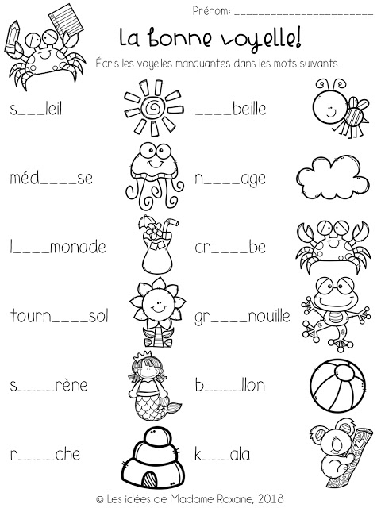

|  |  |  |  |  |  |
| --- | --- | --- | --- | --- | --- |
| o | o | o | u | u | u |
| u | i | i | a | a | e |